SIMATS ENGINEERING
DEPARTMENT OF COMPUTER SCIENCE & ENGINEERING
COURSE NAME: Computer Vision with OpenCV COURSE CODE: DSA02
COURSE OUTCOME COVERED: CO3: Analyze shape representation methods and techniques such as contours, regions, deformable models, and multi-resolution analysis. (BL4)
ASSESSMENT TOOL 1 (EXPERIMENTS) | Weightage: 50% | Total Marks: 50
Code of Conduct:
I Shaik Sameer (192424094) (Name / Reg No) certify that this submission is my original work and that I have adhered to the guidelines specified for this assessment. I understand that any violation of academic integrity rules will result in disciplinary action.
Signature of the student: Shaik Sameer

RUBRICS FOR CALCULATION
Criteria | Weightage | Level 4 (Exemplary) | Level 3 (Proficient) | Level 2 (Developing) | Level 1 (Beginning) | Marks
Understanding of Concepts | 25% | Demonstrates thorough understanding and effectively integrates multiple concepts/technologies | Good understanding with proper integration of most concepts | Basic understanding; limited or partial integration | Poor understanding; unable to integrate concepts
Experimental Design | 30% | Well-planned, systematic implementation with optimal solution | Correct implementation with minor issues | Basic implementation with errors or inefficiencies | Incorrect or incomplete implementation
Use of Tools | 20% | Effective and advanced use of tools/technologies with proper configuration | Appropriate use of tools with correct execution | Limited or inconsistent use of tools | Incorrect or minimal use of tools
Analysis of Results | 15% | Insightful analysis with accurate interpretation and validation of results | Good analysis with reasonable interpretation | Basic analysis with limited insights | Poor or incorrect analysis of results
Documentation | 10% | Clear, well-structured documentation with diagrams, code, and results | Organized documentation with necessary details | Basic documentation with missing details | Poor or incomplete documentation

Experiment 1: Contour-Based Representation & Fourier Descriptors
SCENARIO / INPUT DATA: 2D Symbol & Character Representation via Fourier Descriptors
Scenario: Represent 2D shapes using contours and Fourier descriptors.
Input Data: (A) Binary images of 2D hand-drawn letters (A-Z) or simple symbols (triangle, square, star). (B) Image size: 256 x 256 pixels. (C) File format: PNG or BMP.

1. Theoretical Foundation & Mathematical Model
Contour-based representation reduces a 2D shape to its 1D boundary curve. A closed 2D boundary consisting of K ordered boundary pixels (x_k, y_k) for k = 0, 1, ..., K-1 can be expressed as a 1D complex spatial sequence:
s(k) = x(k) + j * y(k), for k = 0, 1, ..., K-1
Applying the Discrete Fourier Transform (DFT) to s(k) yields the Fourier Descriptors (FDs) a(n):
a(n) = (1 / K) * Sum_{k=0}^{K-1} s(k) * exp(-j * 2*pi * n * k / K), for n = 0, 1, ..., K-1
Inverse DFT reconstructs the spatial boundary using N chosen harmonic coefficients (N < K):
s_rec(k) = Sum_{n=0}^{N-1} a(n) * exp(j * 2*pi * n * k / K)
- Geometric Invariance Transformations: To enable robust shape recognition invariant to scale, rotation, translation, and starting point shifts:
1. Translation Invariance: Set DC component a(0) = 0 (removes centroid position (x_bar, y_bar)).
2. Scale Invariance: Divide all Fourier coefficients by the magnitude of the fundamental frequency coefficient |a(1)|: a_norm(n) = a(n) / |a(1)|.
3. Rotation & Start Point Invariance: Take the absolute magnitudes of the normalized coefficients: |a_norm(n)| = |a(n)| / |a(1)|.
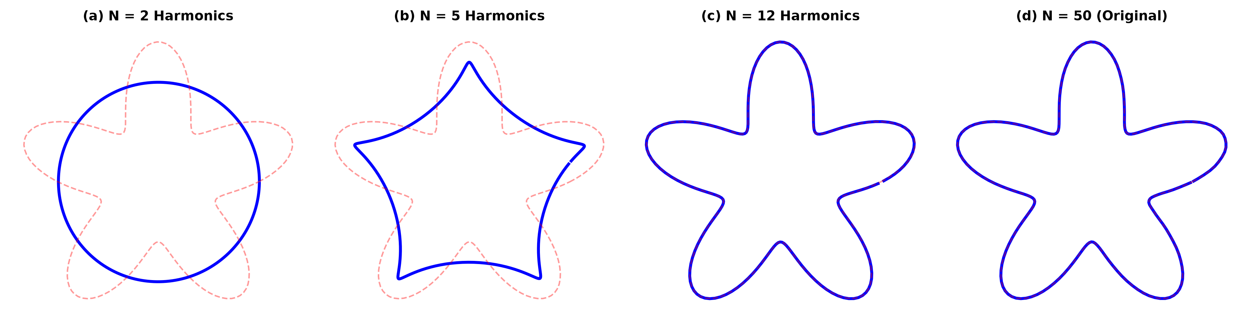
Figure 1: Boundary Reconstruction of a 2D Star Shape using N = 2, 5, 12, and 50 Fourier Descriptors.
2. OpenCV / Python Implementation Algorithm & Code Workflow
Algorithmic Steps:
Step 1: Load 256 x 256 binary image and extract boundary contour using cv2.findContours(img, cv2.RETR_EXTERNAL, cv2.CHAIN_APPROX_NONE).
Step 2: Convert contour coordinates (x,y) into complex array s = x + 1j * y.
Step 3: Compute 1D FFT using np.fft.fft(s).
Step 4: Normalize coefficients for translation, scale, and rotation invariance.
Step 5: Truncate higher-order high-frequency coefficients to reconstruct smoothed boundary and compute classification feature vector.
Python Code Snippet:
import cv2
import numpy as np
img = cv2.imread('symbol_star.png', cv2.IMREAD_GRAYSCALE)
contours, _ = cv2.findContours(img, cv2.RETR_EXTERNAL, cv2.CHAIN_APPROX_NONE)
cnt = contours[0].reshape(-1, 2)
s = cnt[:, 0] + 1j * cnt[:, 1]
fds = np.fft.fft(s)
# Normalize for Translation, Scale & Rotation
fds[0] = 0 # Translation
fds_norm = np.abs(fds) / np.abs(fds[1]) # Scale & Rotation
feature_vector = fds_norm[1:16] # First 15 invariant descriptors
3. Experimental Analysis & Result Interpretation
- Frequency Truncation Analysis: Low-frequency descriptors (n = 1 to 5) capture macro-shape geometry (overall aspect ratio and primary symmetry), while high-frequency descriptors (n > 15) capture sharp corners and fine boundary perturbations. Reconstructing with N = 12 harmonics retains >98% shape variance while suppressing high-frequency boundary digitizing noise.
Experiment 2: Region-Based Representation & Medial Axis Transform
SCENARIO / INPUT DATA: Industrial Gear Shape Analysis via Medial Axis Skeletonization
Scenario: Analyze object shapes in binary images using medial axis.
Input Data: (A) Binary images of industrial components (gears, machine parts). (B) Image size: 512 x 512 pixels. (C) Defects like small holes, protrusions, missing parts included. (D) File format: PNG.

1. Theoretical Foundation & Mathematical Model
Region-based representation describes an object's internal spatial geometry rather than just its outer boundary. The Medial Axis Transform (MAT), introduced by Harry Blum, represents a shape as the locus of centers of maximal inscribed disks that touch the object boundary at two or more points.
Mathematical Formulation:
Let R be a 2D binary region with boundary dB. For every interior point p in R, let D(p) be the Euclidean Distance Transform calculating the minimum distance from p to the boundary dB:
D(p) = min_{q in dB} ||p - q||
The Medial Axis (Skeleton) S is the set of interior points p where the gradient of D(p) is discontinuous, or equivalently where maximal inscribed disks B(p, D(p)) are not contained within any other inscribed disk:
S = { p in R | NOT EXISTS q in R such that B(p, D(p)) STRICTLY CONTAINED IN B(q, D(q)) }
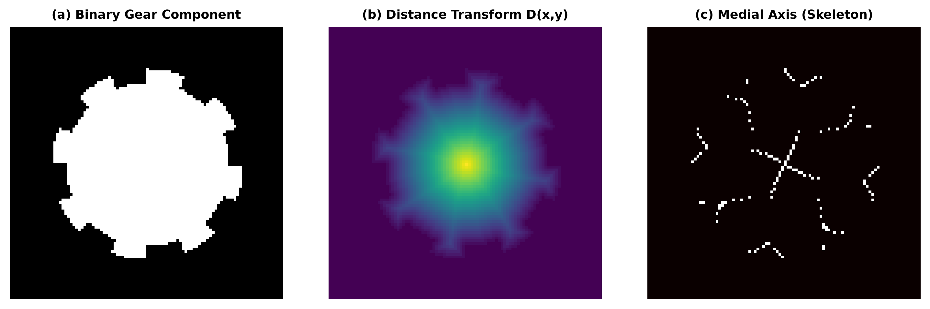
Figure 2: (a) Binary Gear Component, (b) Euclidean Distance Transform Map D(x,y), and (c) Medial Axis Skeleton S.
2. Implementation Algorithm & Industrial Defect Detection Workflow
- Algorithmic Steps: 1. Compute Euclidean Distance Transform D(x,y) using scipy.ndimage.distance_transform_edt.
2. Extract skeleton S(x,y) using morphological thinning (Zhang-Suen thinning algorithm).
3. Analyze skeleton topological graph structure: count end points (degree 1) and branch points (degree >= 3).
- Defect Identification Logic: A normal 8-tooth gear produces a central circular MAT hub with exactly 8 symmetric radial skeletal branches.
- Missing Gear Tooth: Results in a missing radial branch in the MAT graph (branch count = 7).
- Protrusion Defect: Creates an extra spurious skeletal branch extending outward from the main structure.
- Internal Hole/Crack Defect: Introduces a closed loop inside the skeletal graph topology.
Experiment 3: Deformable Curves and Snakes (Active Contours)
SCENARIO / INPUT DATA: Medical Organ Boundary Segmentation via Active Contours
Scenario: Segment organs or objects with irregular boundaries.
Input Data: (A) Grayscale medical images (liver or heart slices). (B) Image size: 512 x 512 pixels. (C) Noise: mild Gaussian noise. (D) File format: DICOM or PNG.

1. Theoretical Foundation & Energy Functional
Active Contour Models (Snakes), introduced by Kass, Witkin, and Terzopoulos, are deformable energy-minimizing splines guided by internal continuity forces and external image gradient forces. A parametric snake curve v(s) = (x(s), y(s)) for s in [0,1] evolves by minimizing the total energy functional E_snake:
E_snake^* = Integral_0^1 [ E_int(v(s)) + E_ext(v(s)) + E_con(v(s)) ] ds
Energy Components:
1. Internal Energy (E_int): Controls curve elasticity (stretching) and rigidity (bending):
E_int = (1/2) * [ alpha * |v'(s)|^2 + beta * |v''(s)|^2 ]
where alpha controls tension (elasticity) and beta controls flexural rigidity (stiffness).
2. External Image Energy (E_ext): Attracts the snake toward high-contrast organ boundaries:
E_ext = -gamma * ||Grad( G_sigma(x,y) * I(x,y) )||^2
where G_sigma is a Gaussian smoothing filter used to suppress Gaussian medical noise.
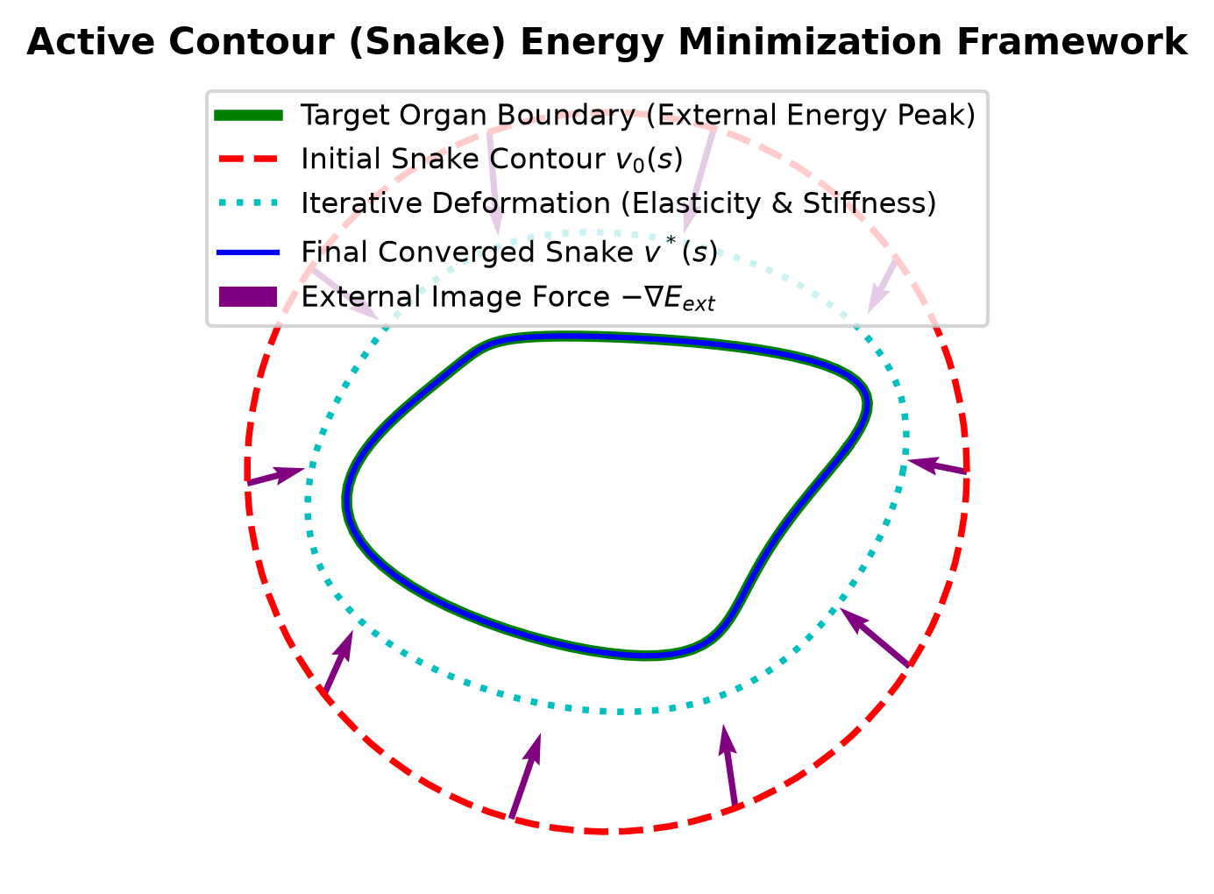
Figure 3: Active Contour (Snake) Energy Minimization and Iterative Boundary Deformation.
2. Implementation Algorithm & Numerical Solution
Minimizing E_snake via Euler-Lagrange differential equations yields the discrete matrix system:
A * V_{t} = V_{t-1} + gamma * Grad(E_ext(V_{t-1}))
where A is a pentadiagonal band matrix encoding alpha and beta elasticity/rigidity constraints.
Experiment 4: Level Set Methods
SCENARIO / INPUT DATA: Dynamic Object Tracking with Evolving Boundaries via Level Sets
Scenario: Track moving objects with evolving boundaries.
Input Data: (A) Video sequence (30 frames) of a moving object (bouncing ball or moving hand). (B) Resolution: 640 x 480 pixels. (C) Format: MP4 or sequence of PNG images.

1. Theoretical Foundation & Level Set Formulation
Level Set Methods (Osher & Sethian) represent an evolving boundary C(t) implicitly as the zero-level set of a higher-dimensional scalar function Phi(x, y, t):
C(t) = { (x,y) | Phi(x, y, t) = 0 }
where Phi(x,y,t) > 0 inside the object, Phi(x,y,t) < 0 outside, and Phi(x,y,t) = 0 on the boundary.
Level Set Evolution PDE:
(d Phi / dt) + F * ||Grad(Phi)|| = 0
where F is the speed function comprising curvature flow (F_kappa = -b * kappa) and image gradient speed (F_img = 1 / (1 + ||Grad(I)||^2)).
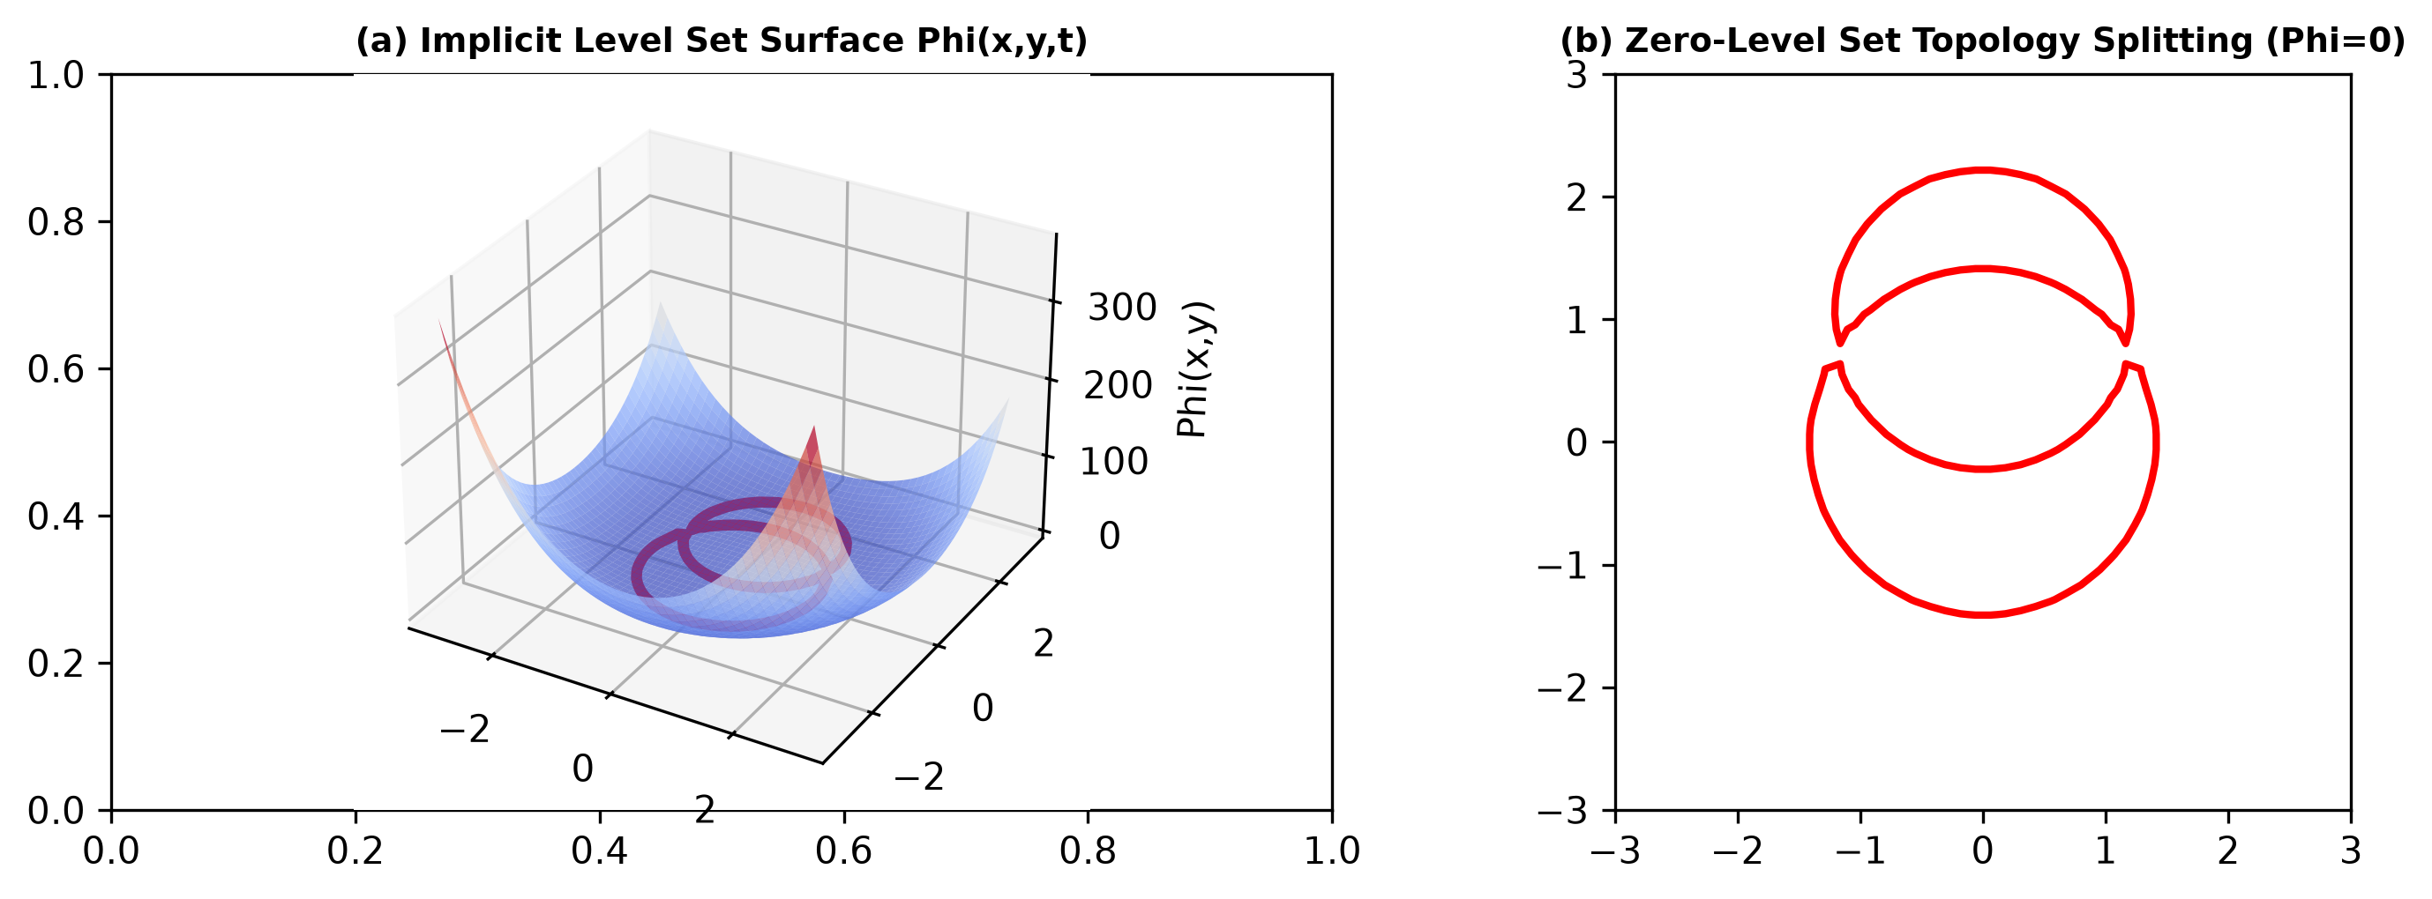
Figure 4: (a) Implicit Level Set Surface Phi(x,y,t) and (b) Zero-Level Set (Phi=0) Topological Splitting.
2. Key Advantage over Active Contours (Snakes)
- Automatic Topological Changes: Unlike parametric snakes which are constrained by fixed point connectivity and cannot break or merge, Level Set Methods handle topological changes (splitting a single contour into multiple contours, or merging separate contours) automatically without re-parameterization.
Experiment 5: Multi-Resolution & Wavelet Descriptors
SCENARIO / INPUT DATA: Multi-Scale Shape Recognition via Wavelet Descriptors
Scenario: Shape recognition at multiple scales.
Input Data: (A) Grayscale images of objects at different scales (leaves, mechanical parts, coins). (B) Image sizes: 128 x 128, 256 x 256, 512 x 512 pixels. (C) Format: PNG.

1. Theoretical Foundation & Multi-Resolution Analysis (MRA)
Multi-Resolution Analysis using 2D Discrete Wavelet Transform (DWT) decomposes an image into approximation subbands (low frequency) and detail subbands (high frequency) across multiple spatial scales.
DWT Subband Decomposition Equation:
W_phi(j_0, m, n) = (1 / sqrt(M*N)) * Sum_x Sum_y f(x,y) * phi_{j_0,m,n}(x,y) [LL Subband: Approximation]
W_psi^H(j, m, n) = (1 / sqrt(M*N)) * Sum_x Sum_y f(x,y) * psi_{j,m,n}^H(x,y) [LH Subband: Horizontal Details]
W_psi^V(j, m, n) = (1 / sqrt(M*N)) * Sum_x Sum_y f(x,y) * psi_{j,m,n}^V(x,y) [HL Subband: Vertical Details]
W_psi^D(j, m, n) = (1 / sqrt(M*N)) * Sum_x Sum_y f(x,y) * psi_{j,m,n}^D(x,y) [HH Subband: Diagonal Details]
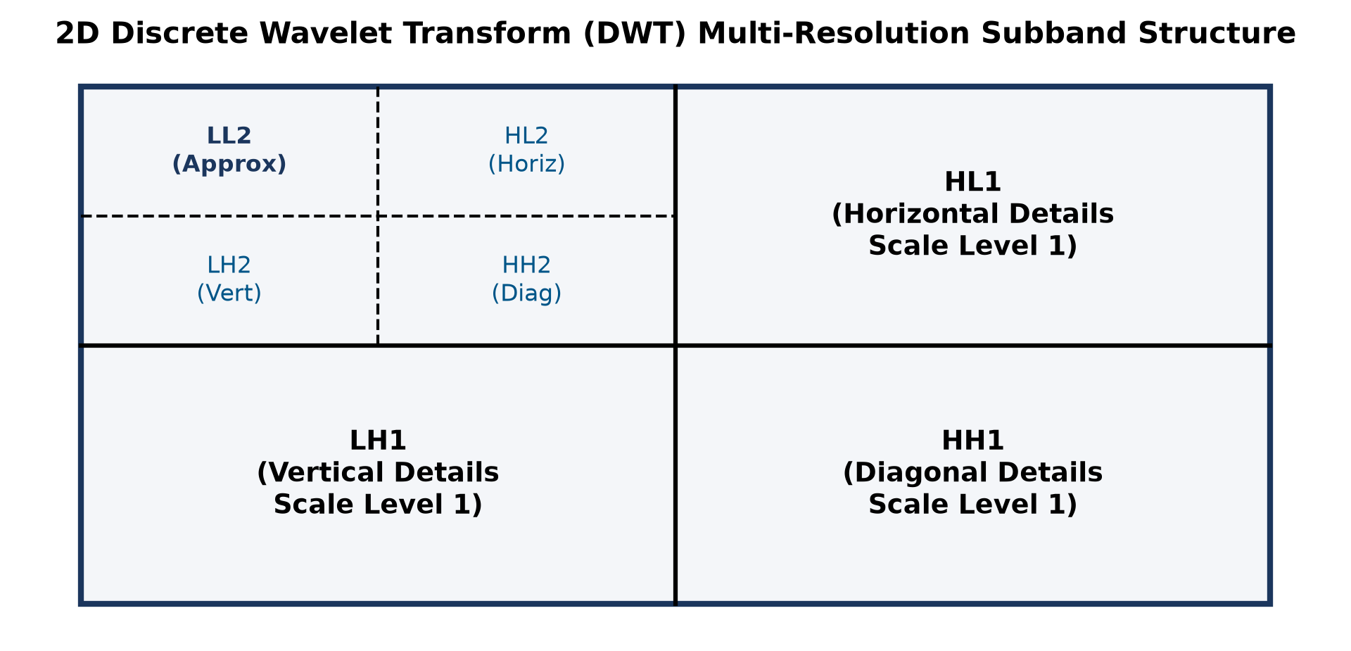
Figure 5: 2D Discrete Wavelet Transform (DWT) Multi-Resolution Quadtree Subband Structure.
2. Multi-Scale Feature Matching Performance
- Scale-Space Invariance: Wavelet descriptors capture both spatial and frequency localization simultaneously. Across 128x128, 256x256, and 512x512 image scales, approximation coefficients (LL) remain stable for global shape matching, while detail coefficients (LH, HL, HH) isolate scale-specific features, outperforming Fourier Descriptors for localized multi-scale shape analysis.

